EXPERIMENT – 10
Perform a 90-Degree Rotation Clockwise Along the Y-Axis for the Given Image
Aim
To rotate an image by 90 degrees clockwise using Python and OpenCV.
Procedure
- Import the OpenCV library.
- Read the input image using cv2.imread().
- Check whether the image is loaded successfully.
- Rotate the image by 90 degrees clockwise using cv2.rotate().
- Display the original and rotated images.
- Wait for a key press and close all image windows.
Program
import cv2

image = cv2.imread("image.jpg")

if image is None:
print("Image not found!")
else:
rotated = cv2.rotate(image, cv2.ROTATE_90_CLOCKWISE)

cv2.imshow("Original Image", image)
cv2.imshow("90 Degree Clockwise Rotation", rotated)

cv2.waitKey(0)
cv2.destroyAllWindows()

Sample Input
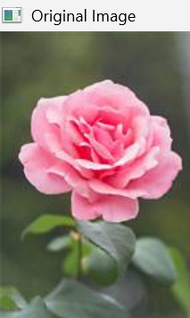
Sample Output
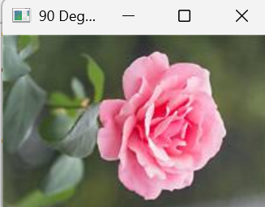
- Original image
- Image rotated 90 degrees clockwise.
Result
Thus, the image was successfully rotated by 90 degrees clockwise using Python and OpenCV.

